EXPERIMENT III

AIM:
To identify and handle missing values, duplicate records, and outliers in the NBA Play-by-Play dataset (pbp2026.csv) and perform data transformation techniques such as normalization, label encoding, and one-hot encoding using Python, Pandas, and Scikit-Learn.

ALGORITHM:
- Import the required Python libraries.
- Load the NBA Play-by-Play dataset (pbp2026.csv) using Pandas.
- Display the first few records and check the dataset dimensions.
- Identify and count missing values in each column.
- Replace missing numerical values with the mean and categorical values with the mode.
- Detect and remove duplicate records from the dataset.
- Identify outliers in numerical columns using the Interquartile Range (IQR) method.
- Visualize the outliers using a box plot.
- Normalize selected numerical columns using Min-Max Scaling.
- Convert categorical variables into numerical format using Label Encoding.
- Apply One-Hot Encoding to categorical variables.
- Display the cleaned dataset, statistical summary, and save the processed dataset.

PROGRAM:
# ============================================================
# EXPERIMENT 3
# EXPLORATORY DATA ANALYSIS (EDA)
# DATA CLEANING AND DATA TRANSFORMATION
# Dataset: pbp2026.csv (NBA Play-by-Play Dataset)
# ============================================================

# -----------------------------
# Import Libraries
# -----------------------------
import pandas as pd
import numpy as np
import matplotlib.pyplot as plt
from sklearn.preprocessing import MinMaxScaler, LabelEncoder

# -----------------------------
# Load Dataset
# -----------------------------
df = pd.read_csv("pbp2026.csv")

print("="*80)
print("FIRST 5 ROWS")
print("="*80)
print(df.head())

print("\n" + "="*80)
print("LAST 5 ROWS")
print("="*80)
print(df.tail())

print("\nDataset Shape :", df.shape)

# ============================================================
# PROGRAM 1
# IDENTIFY MISSING VALUES
# ============================================================

print("\n" + "="*80)
print("MISSING VALUES")
print("="*80)

print(df.isnull())

# ============================================================
# PROGRAM 2
# COUNT MISSING VALUES
# ============================================================

print("\n" + "="*80)
print("COUNT OF MISSING VALUES")
print("="*80)

print(df.isnull().sum())

# ============================================================
# PROGRAM 3
# REPLACE MISSING VALUES
# ============================================================

print("\n" + "="*80)
print("REPLACING MISSING VALUES")
print("="*80)

# Numerical Columns
numeric_cols = df.select_dtypes(include=np.number).columns

# Categorical Columns
categorical_cols = df.select_dtypes(include="str").columns

# Fill Numerical Missing Values with Mean
for col in numeric_cols:
df[col] = df[col].fillna(df[col].mean())

# Fill Categorical Missing Values with Mode
for col in categorical_cols:
df[col] = df[col].fillna(df[col].mode()[0])

print("Missing Values After Filling\n")
print(df.isnull().sum())

# ============================================================
# PROGRAM 4
# REMOVE DUPLICATE RECORDS
# ============================================================

print("\n" + "="*80)
print("DUPLICATE RECORDS")
print("="*80)

duplicates = df.duplicated().sum()

print("Duplicate Rows Before Removal :", duplicates)

df.drop_duplicates(inplace=True)

print("Duplicate Rows After Removal :", df.duplicated().sum())

print("Dataset Shape :", df.shape)

# ============================================================
# PROGRAM 5
# DETECT OUTLIERS
# ============================================================

print("\n" + "="*80)
print("OUTLIER DETECTION")
print("="*80)

numeric_columns = ["period", "h_pts", "a_pts", "x", "y", "dist"]

for col in numeric_columns:

Q1 = df[col].quantile(0.25)
Q3 = df[col].quantile(0.75)

IQR = Q3 - Q1

lower = Q1 - 1.5 * IQR
upper = Q3 + 1.5 * IQR

outliers = df[(df[col] < lower) | (df[col] > upper)]

print(f"{col} : {len(outliers)} Outliers")

# -----------------------------
# Box Plot
# -----------------------------

plt.figure(figsize=(8,5))
plt.boxplot(df["dist"])
plt.title("Box Plot of Shot Distance (dist)")
plt.ylabel("Distance (ft)")
plt.grid(True)
plt.show()

# ============================================================
# PROGRAM 6
# NORMALIZATION
# ============================================================

print("\n" + "="*80)
print("MIN-MAX NORMALIZATION")
print("="*80)

scaler = MinMaxScaler()

columns_to_normalize = [
"period",
"h_pts",
"a_pts",
"x",
"y",
"dist"
]

df[columns_to_normalize] = scaler.fit_transform(df[columns_to_normalize])

print(df[columns_to_normalize].head())

# Histogram

plt.figure(figsize=(8,5))
plt.hist(df["dist"], bins=30)
plt.title("Normalized Shot Distance (dist)")
plt.xlabel("Distance")
plt.ylabel("Frequency")
plt.grid(True)
plt.show()

# ============================================================
# PROGRAM 7
# LABEL ENCODING
# ============================================================

print("\n" + "="*80)
print("LABEL ENCODING")
print("="*80)

label_columns = df.select_dtypes(include="str").columns

encoder = LabelEncoder()

for col in label_columns:
df[col] = encoder.fit_transform(df[col])

print(df.head())

# ============================================================
# PROGRAM 8
# ONE HOT ENCODING
# ============================================================

print("\n" + "="*80)
print("ONE HOT ENCODING")
print("="*80)

onehot_columns = ["team", "type", "result"]

df_onehot = pd.get_dummies(
df,
columns=onehot_columns,
dtype=int
)

print(df_onehot.head())

# ============================================================
# FINAL DATASET
# ============================================================

print("\n" + "="*80)
print("FINAL CLEANED DATASET")
print("="*80)

print(df.head())

# ============================================================
# DATASET INFORMATION
# ============================================================

print("\n" + "="*80)
print("DATASET INFORMATION")
print("="*80)

print(df.info())

# ============================================================
# STATISTICAL SUMMARY
# ============================================================

print("\n" + "="*80)
print("STATISTICAL SUMMARY")
print("="*80)

print(df.describe())

# ============================================================
# SAVE CLEANED DATASET
# ============================================================

df.to_csv("pbp2026_Cleaned.csv", index=False)

print("\nCleaned dataset saved successfully as 'pbp2026_Cleaned.csv'")

OUTPUT:
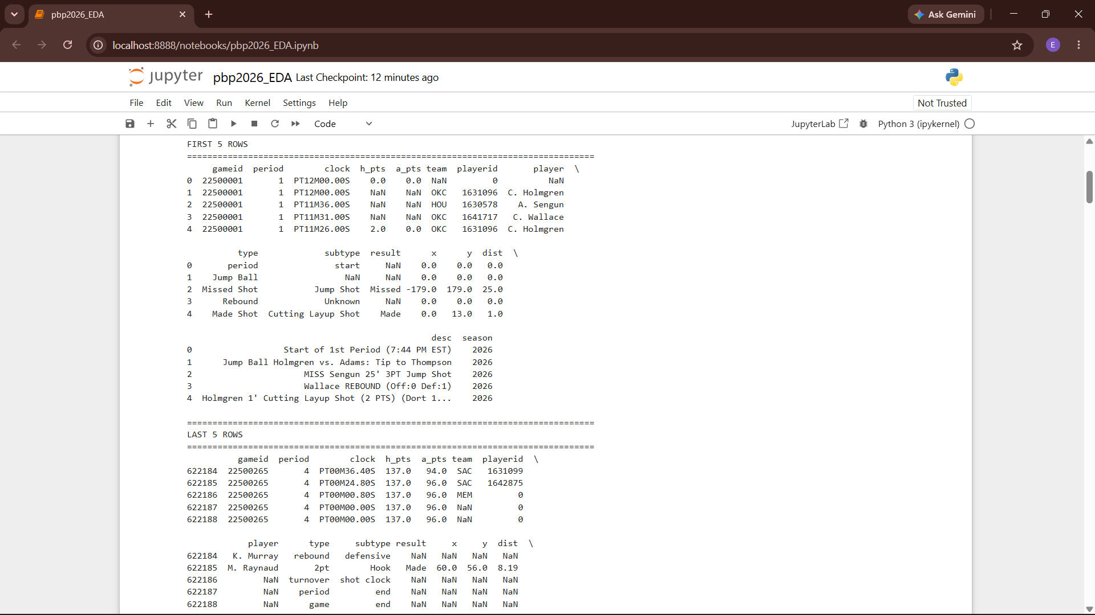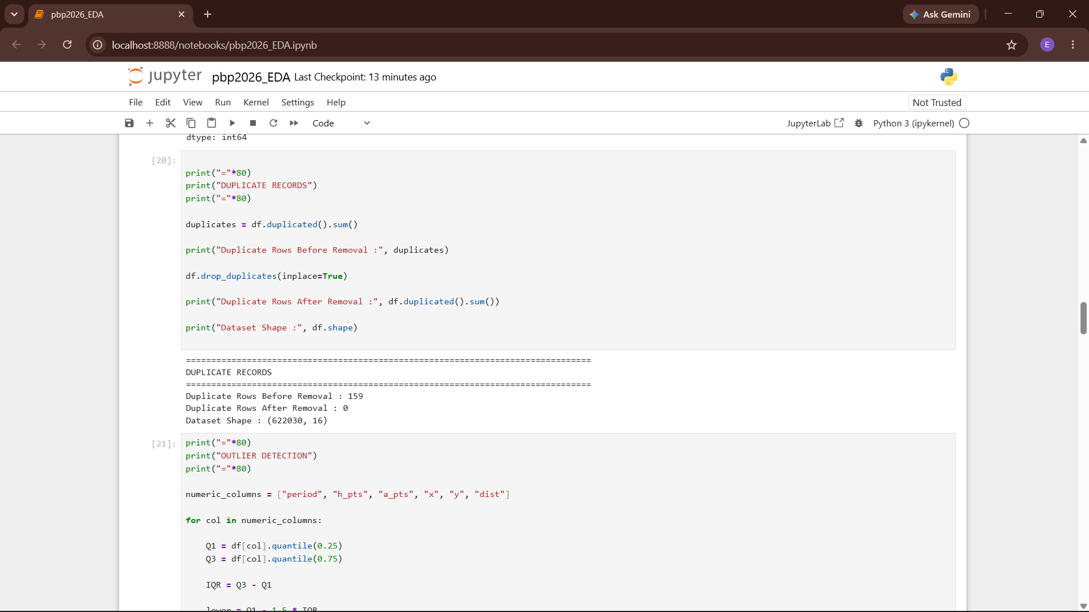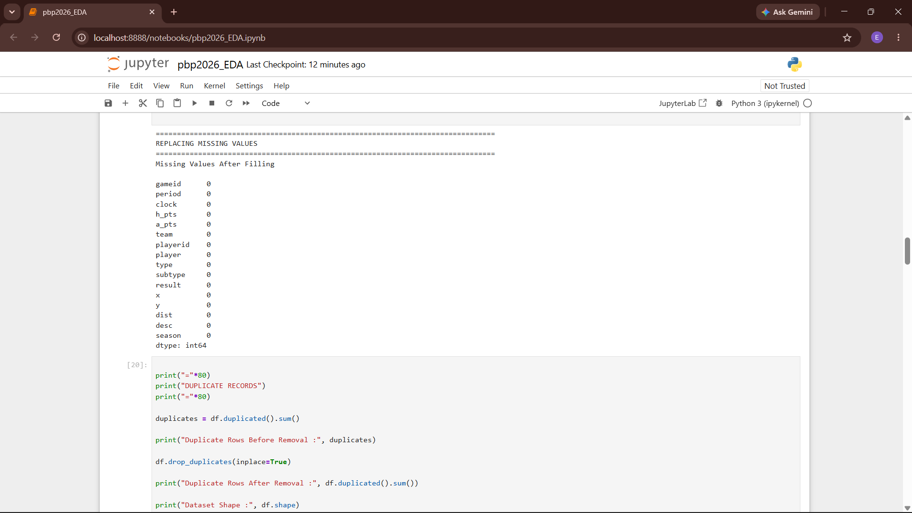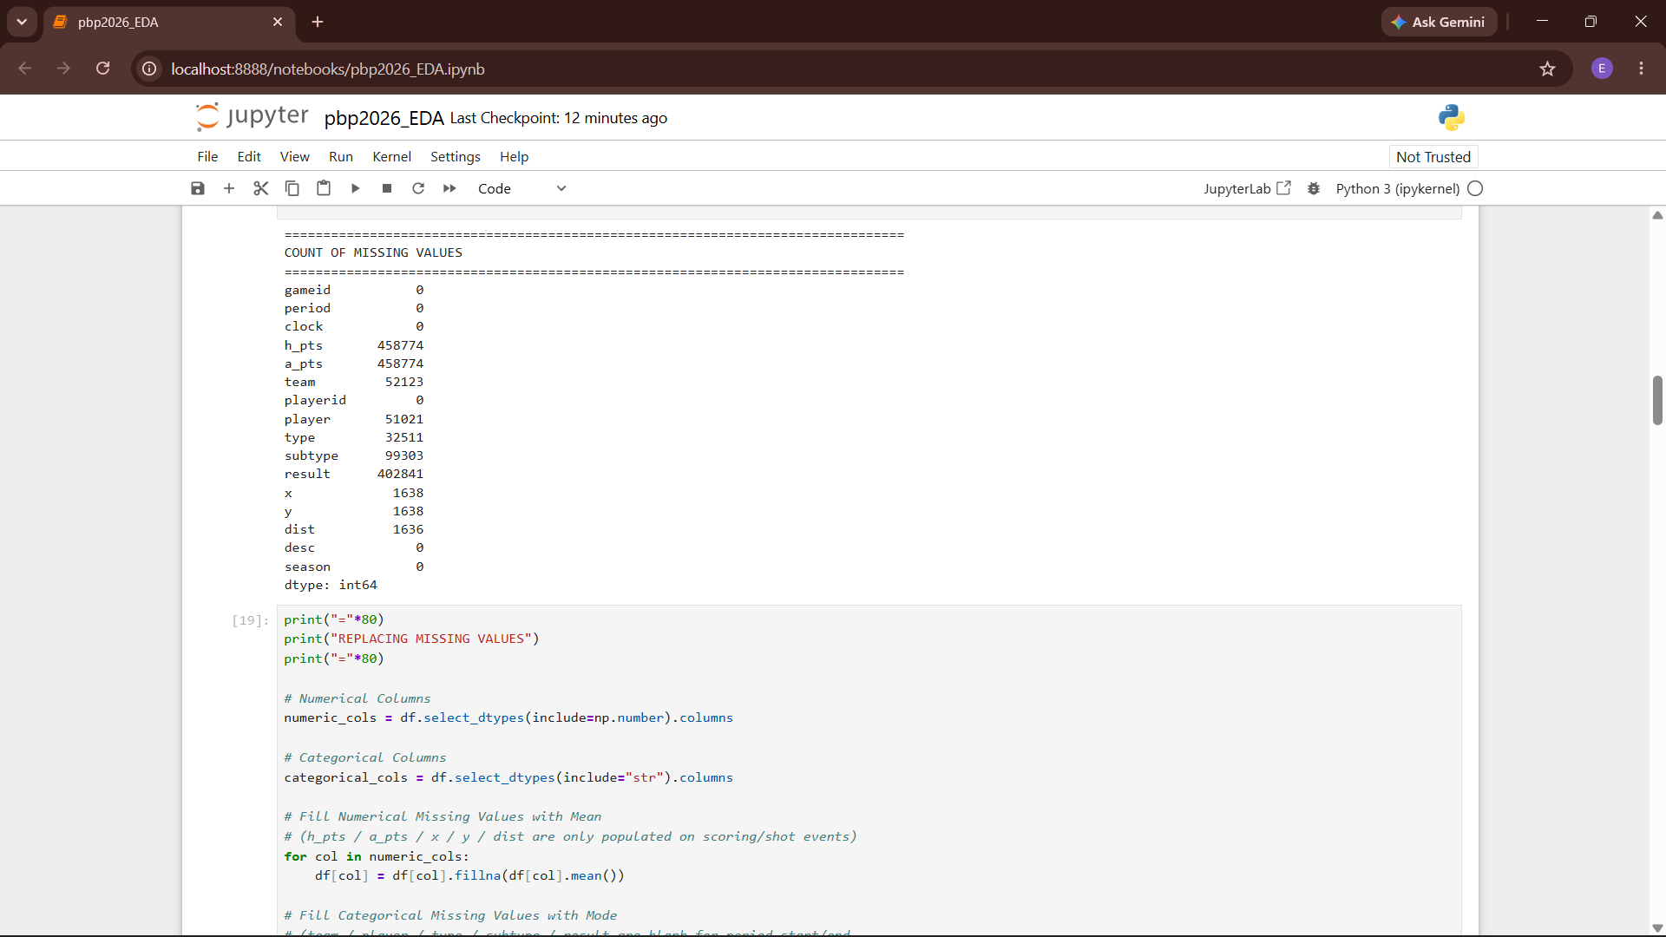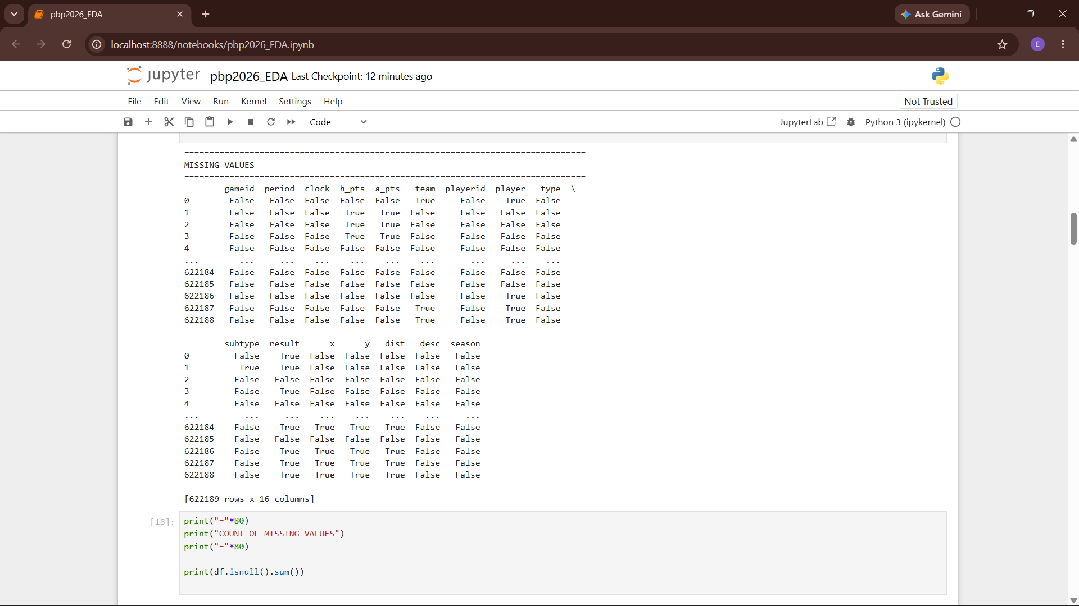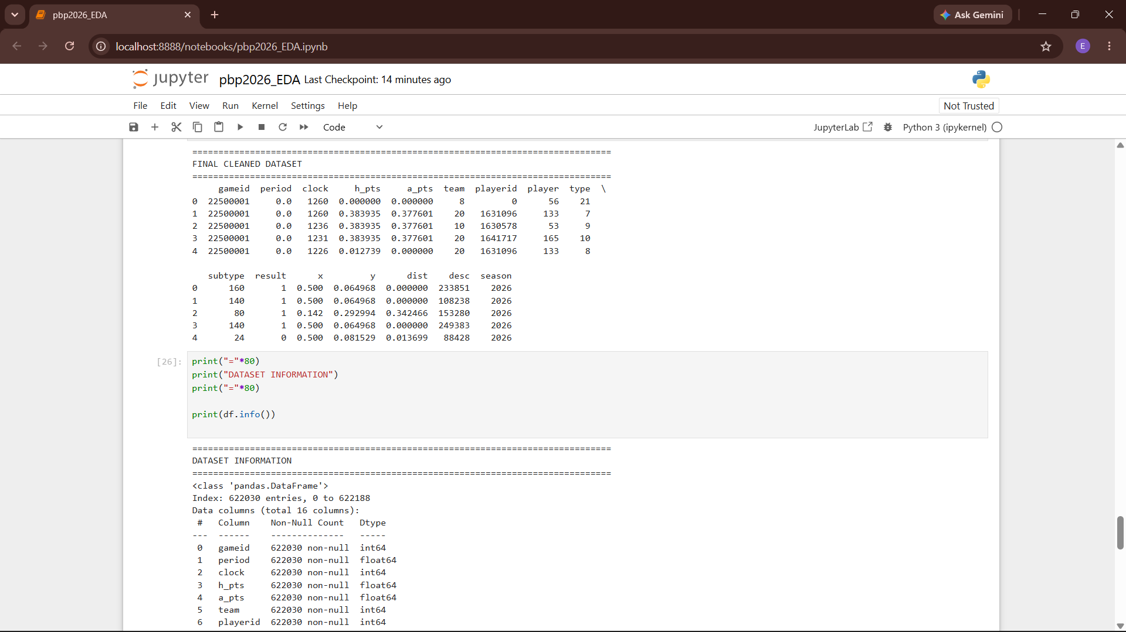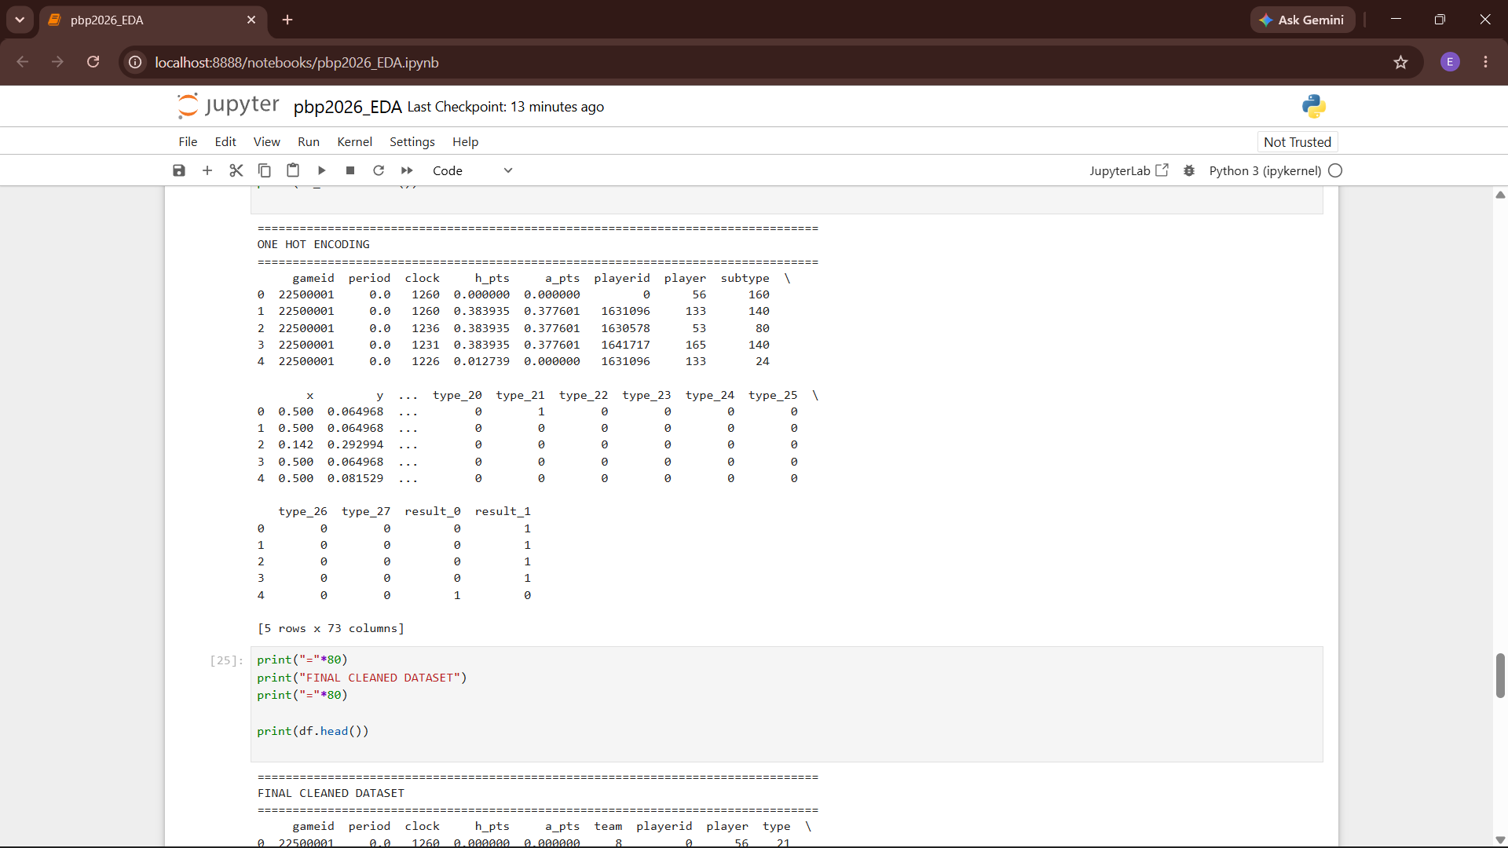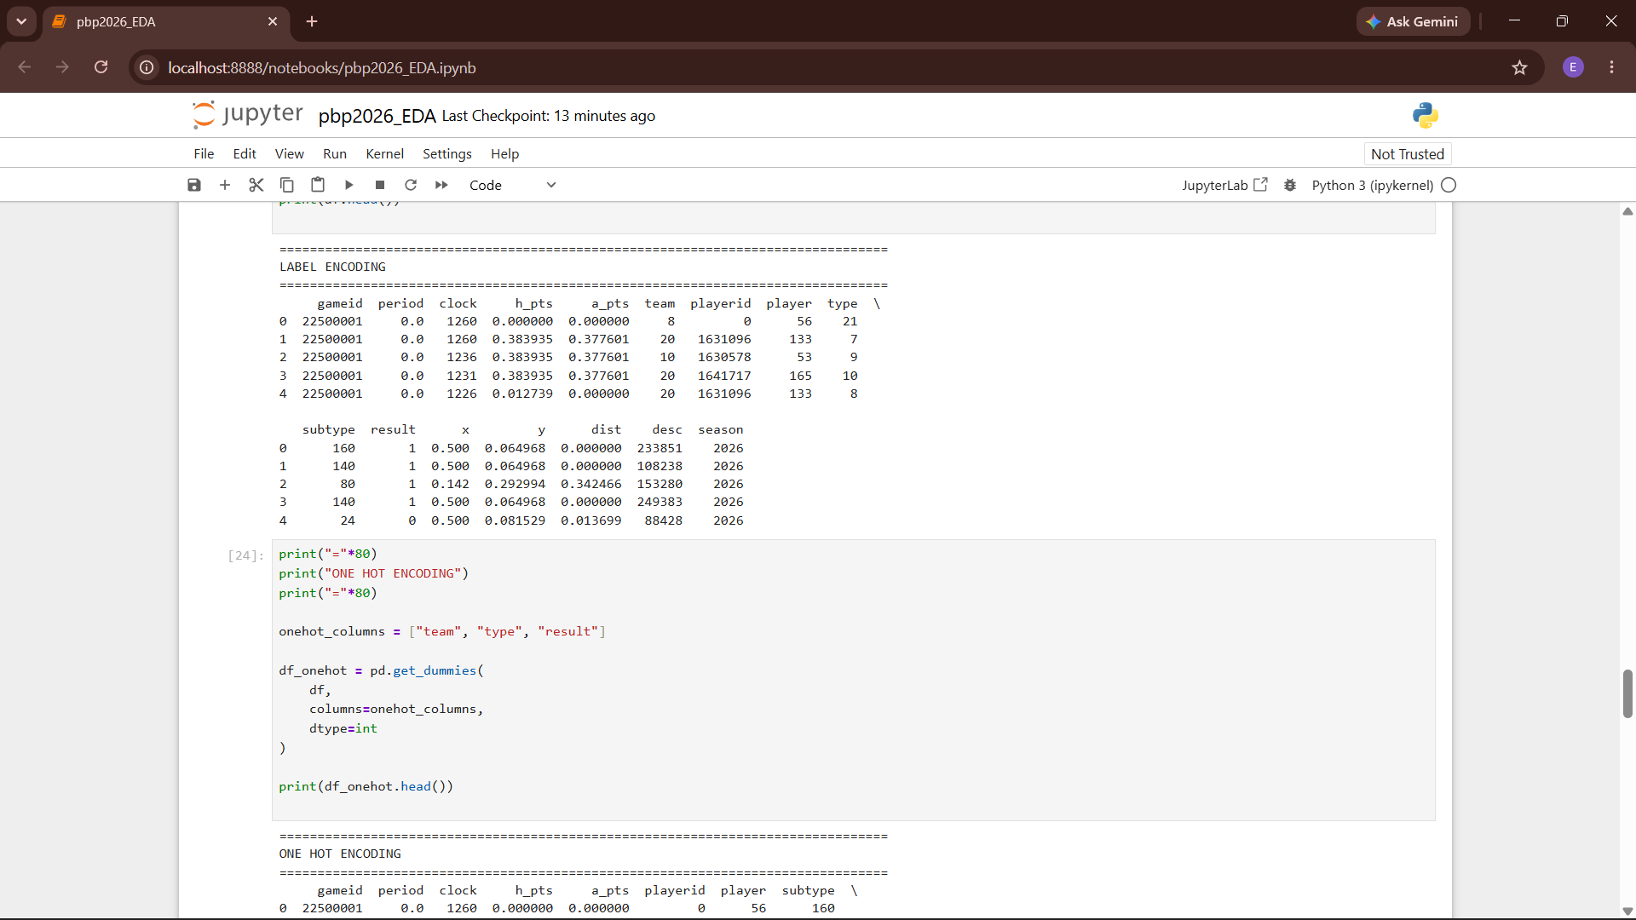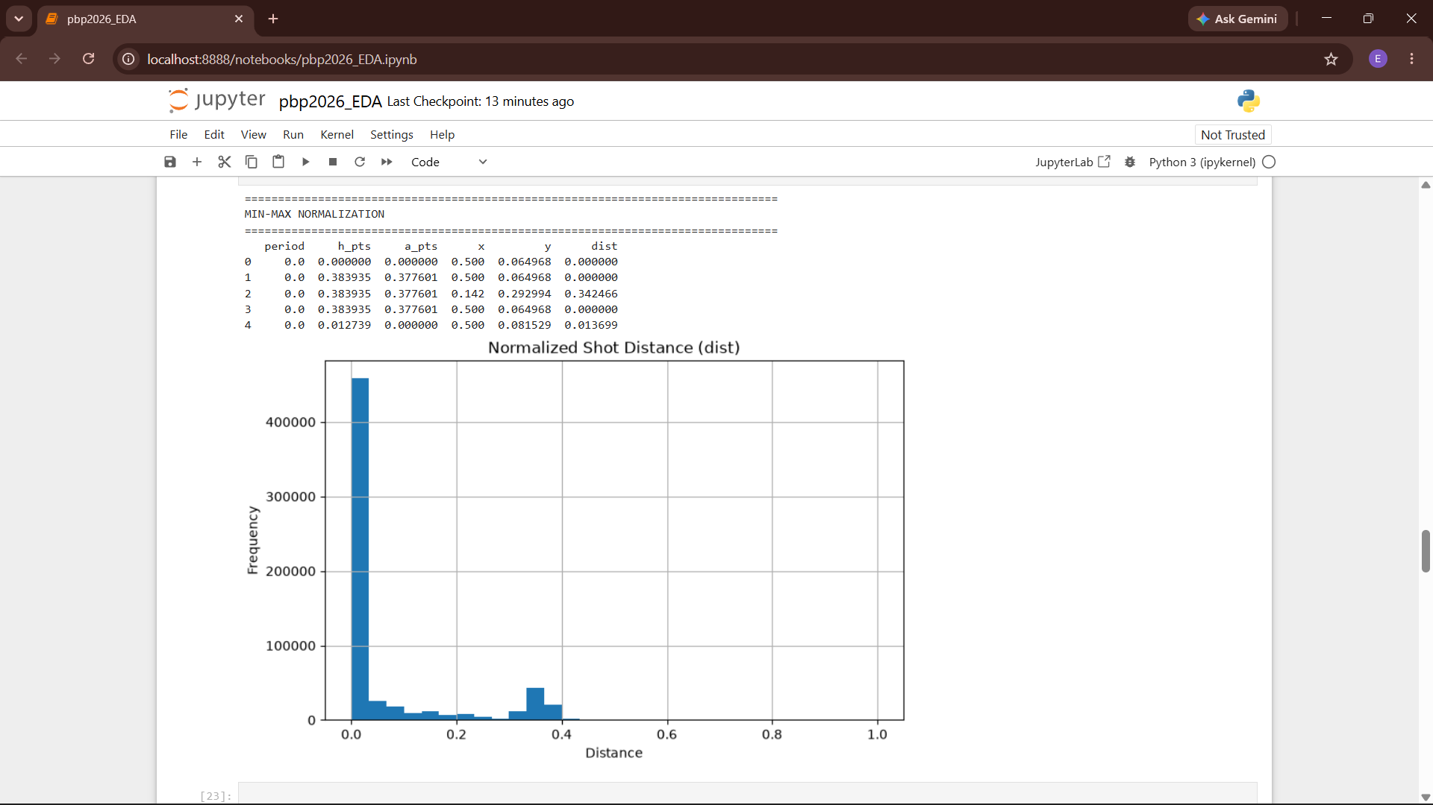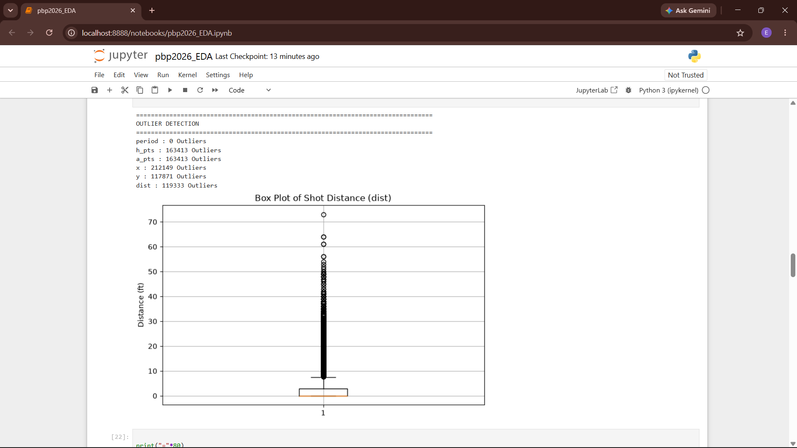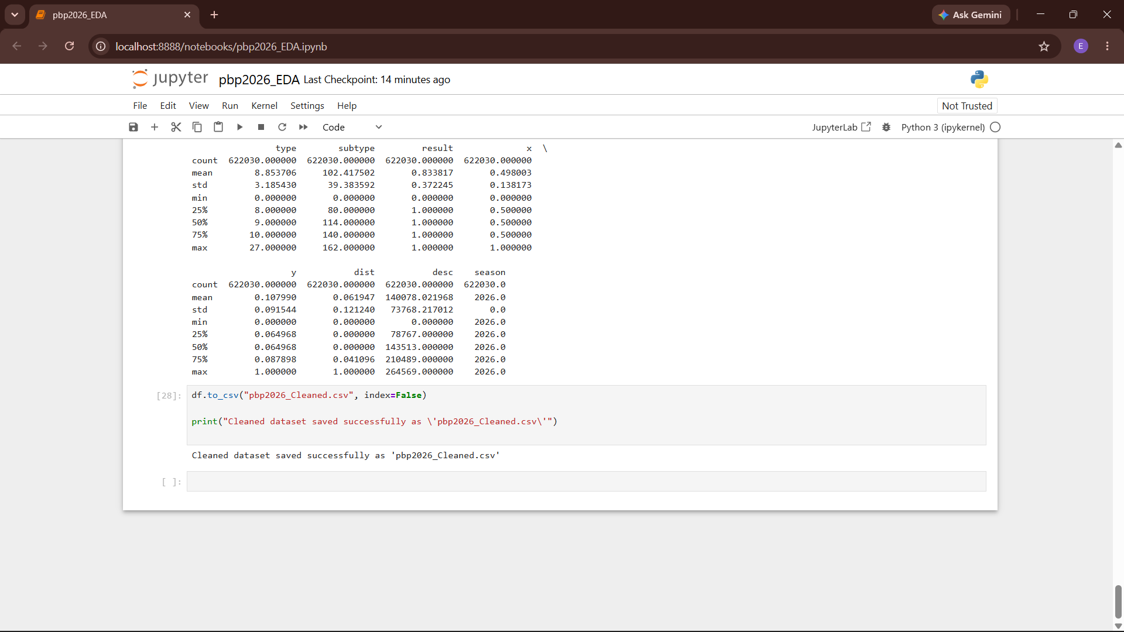
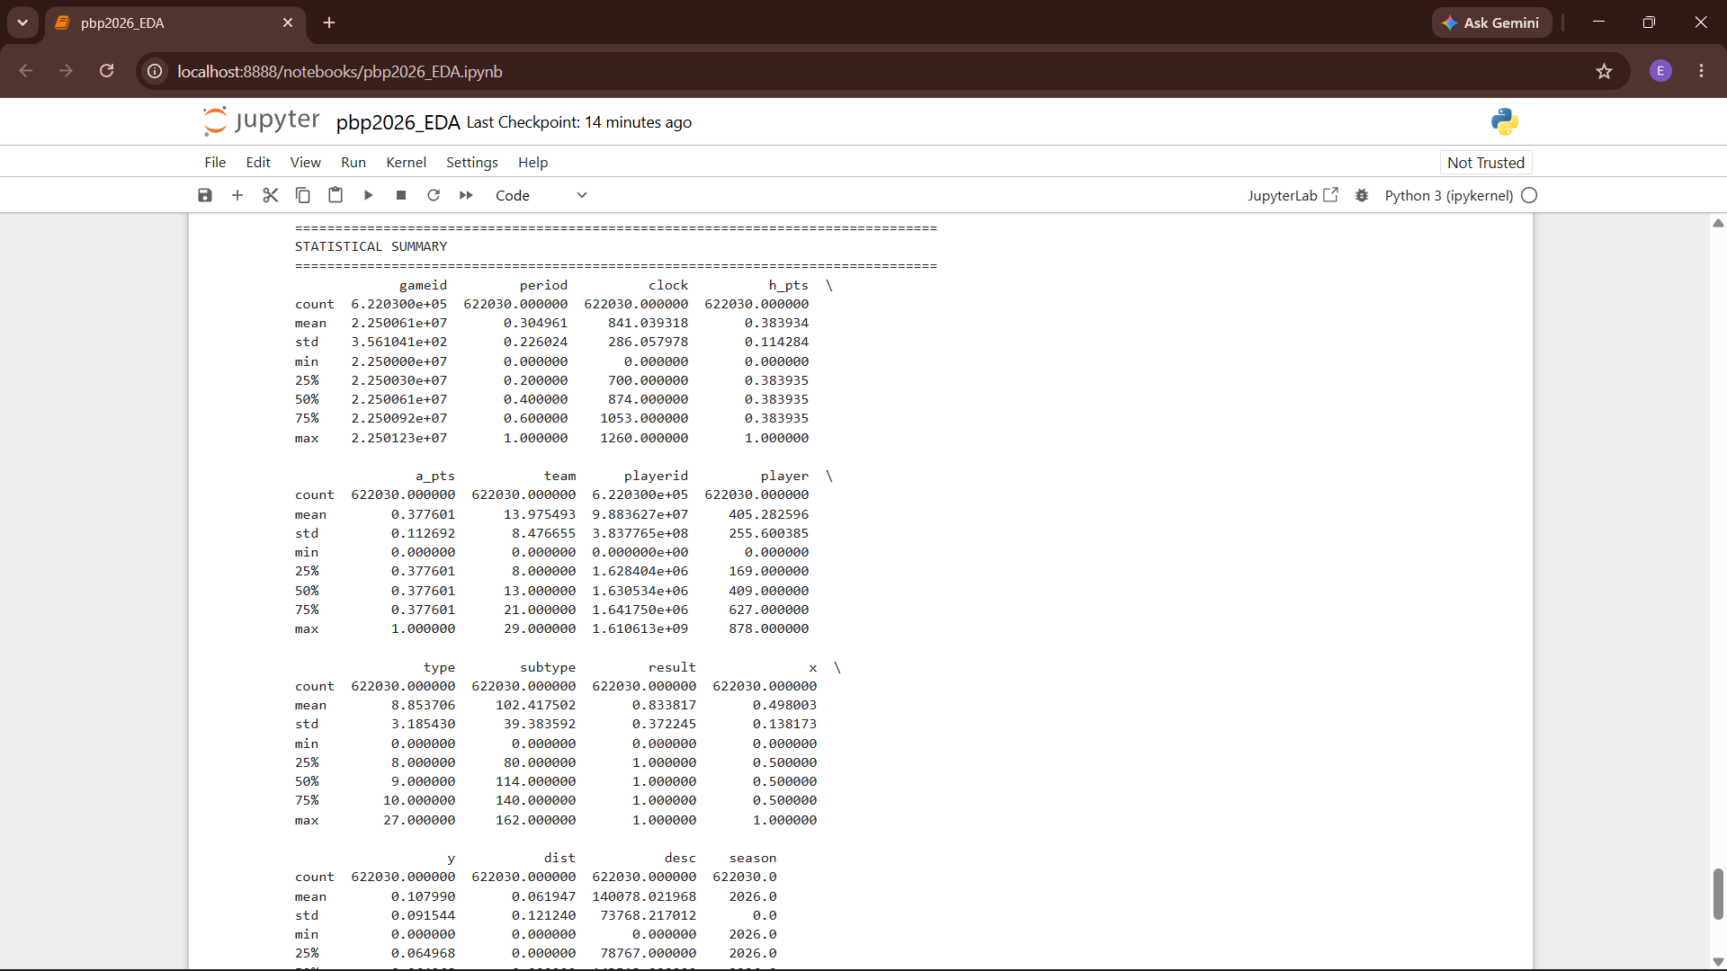

Result:
Thus, the python code used to identify and handle missing values, duplicate records, and outliers in the NBA Play-by-Play dataset, has been successfully executed.

